Approach 1: Predicting the number of rings

Case 1:

Data Pre-processing

Filter: NumerictoNominal

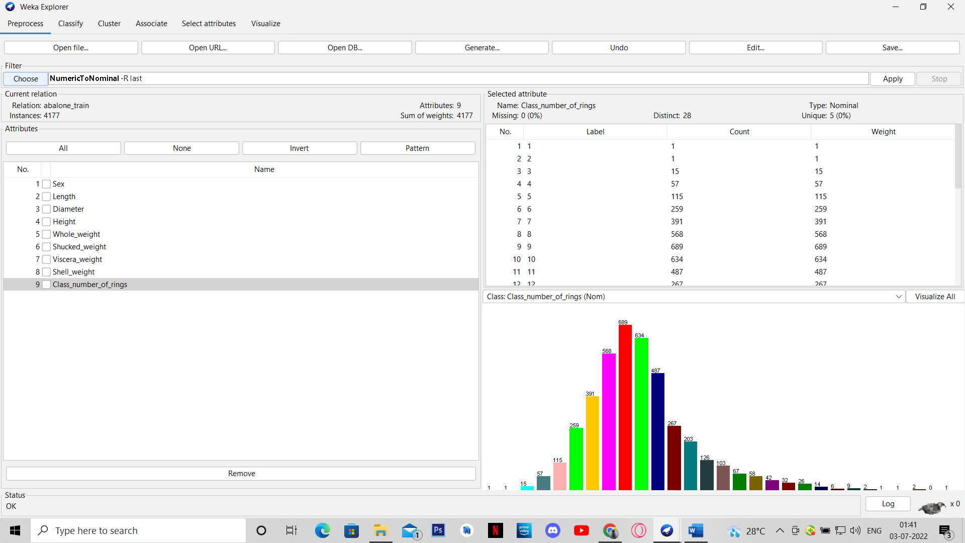

Building the classification model

Training:

Algorithm: J48 Decision Tree

Decision tree generated

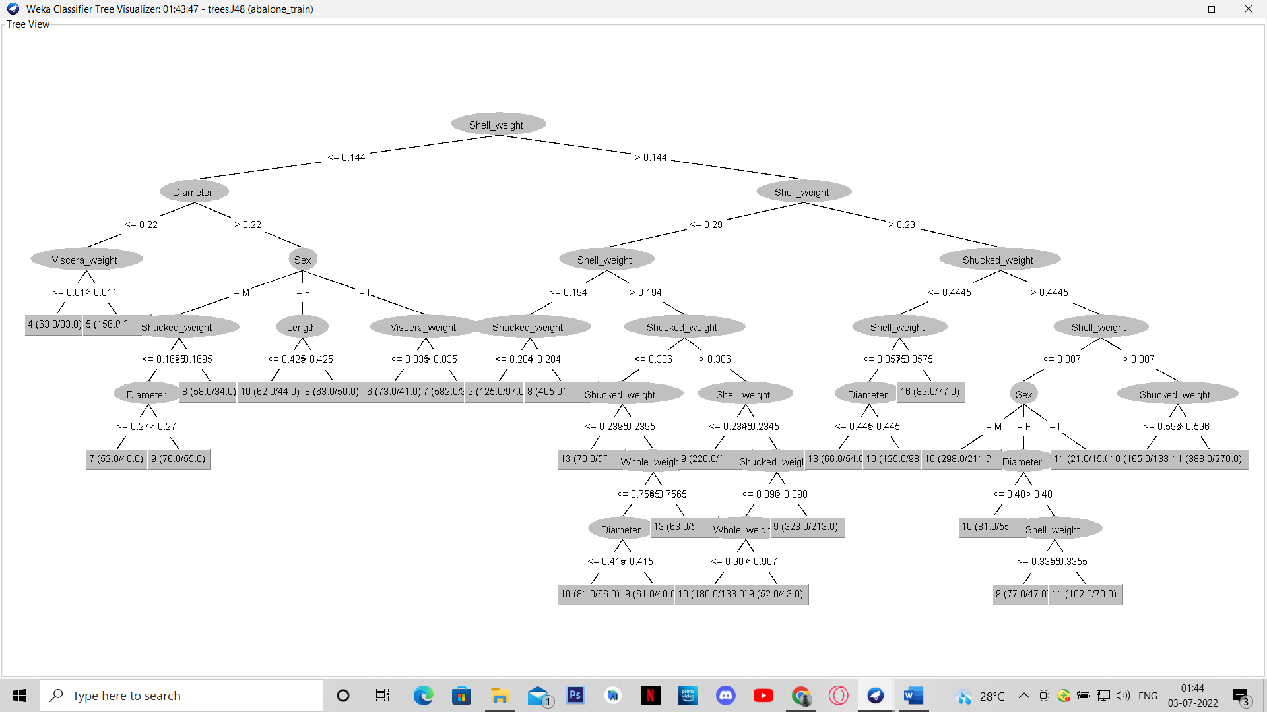

Testing:

Using the model built above

Prediction of number of rings

(taken 35 instances for screenshot)

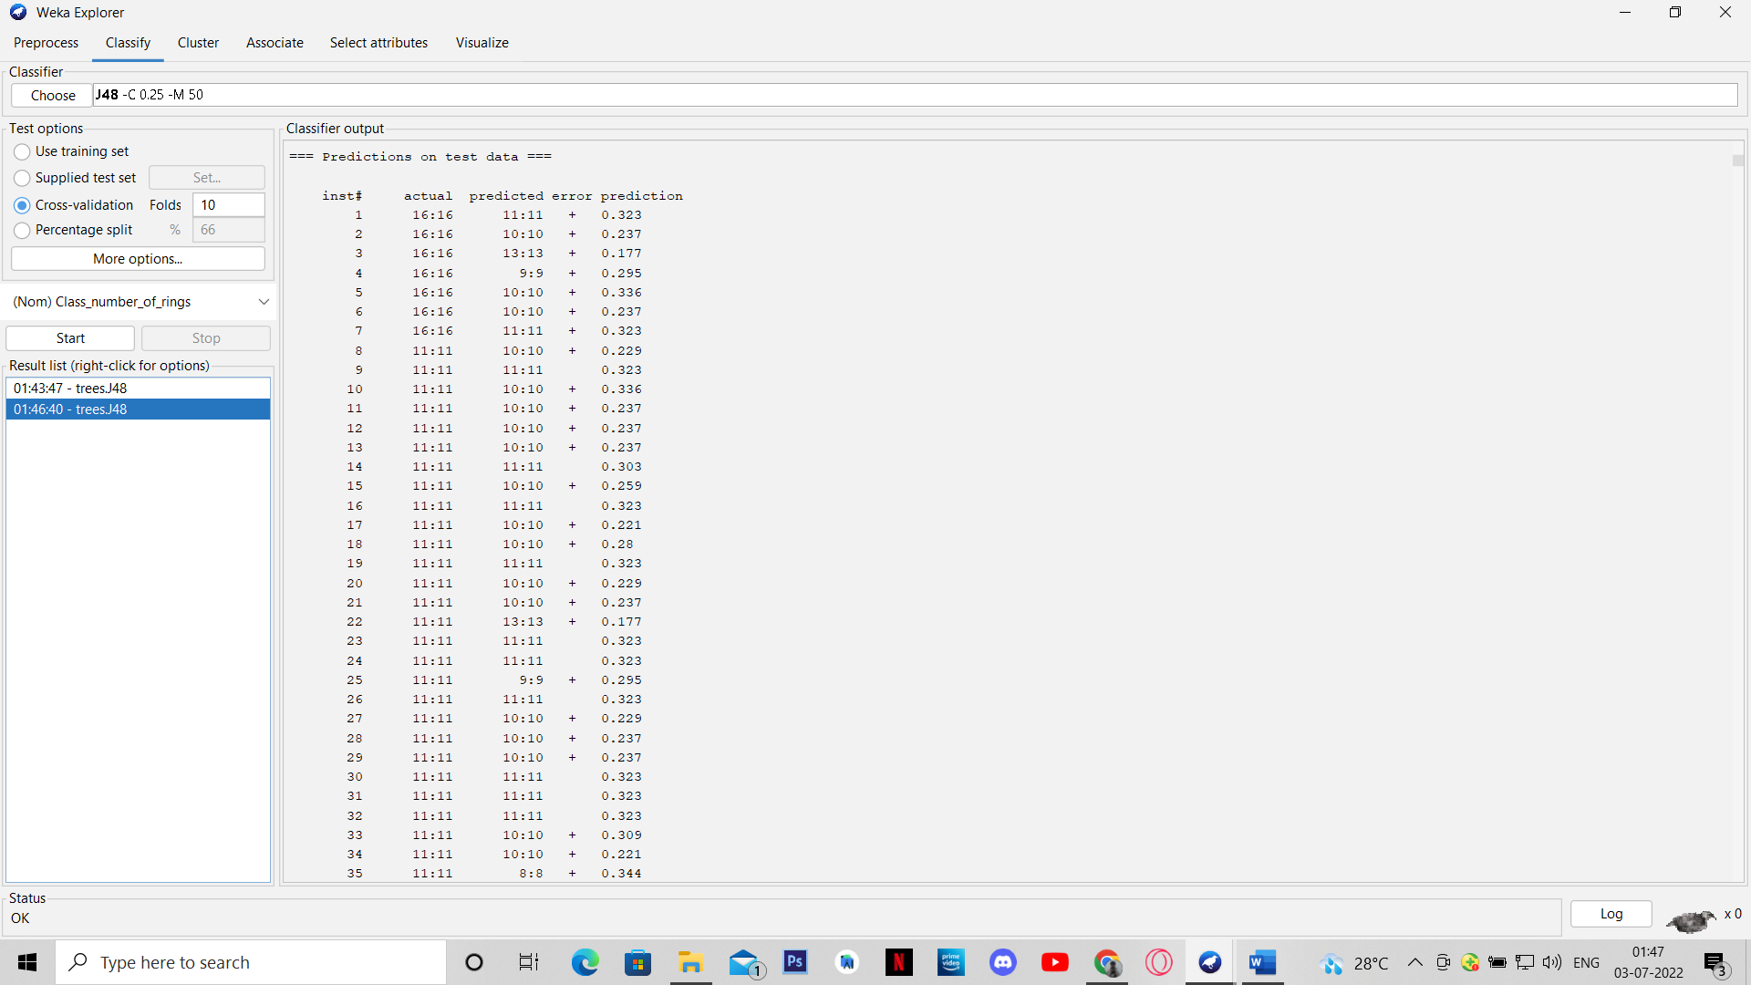

Accuracy

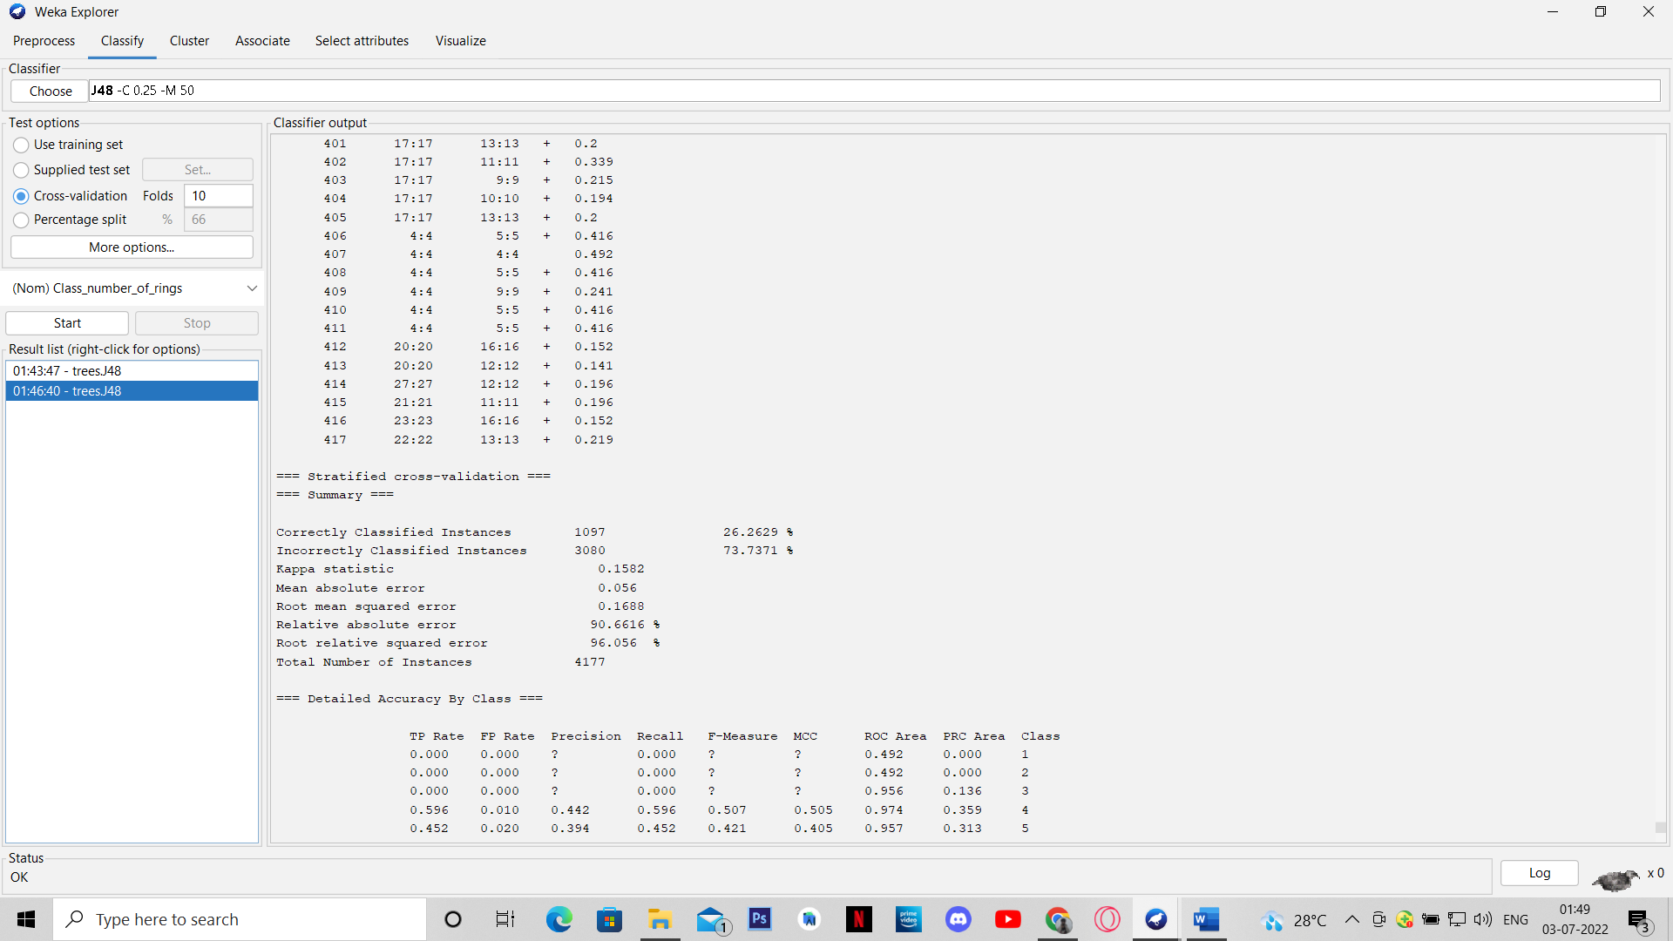

Confusion Matrix

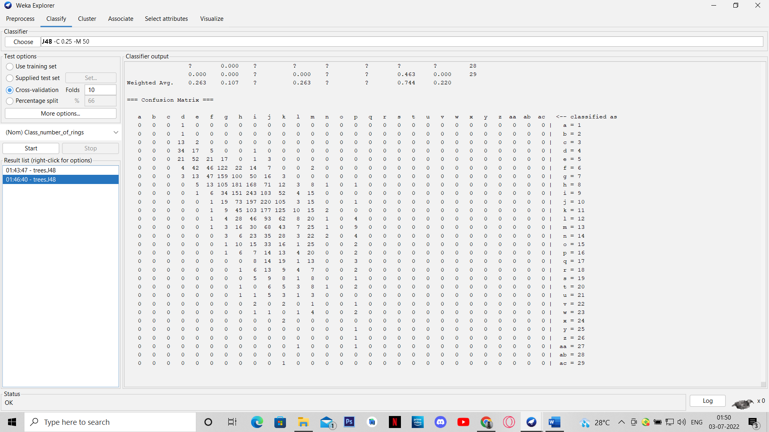

Case 2:

Data Pre-processing

Filter: RemoveMisclassified

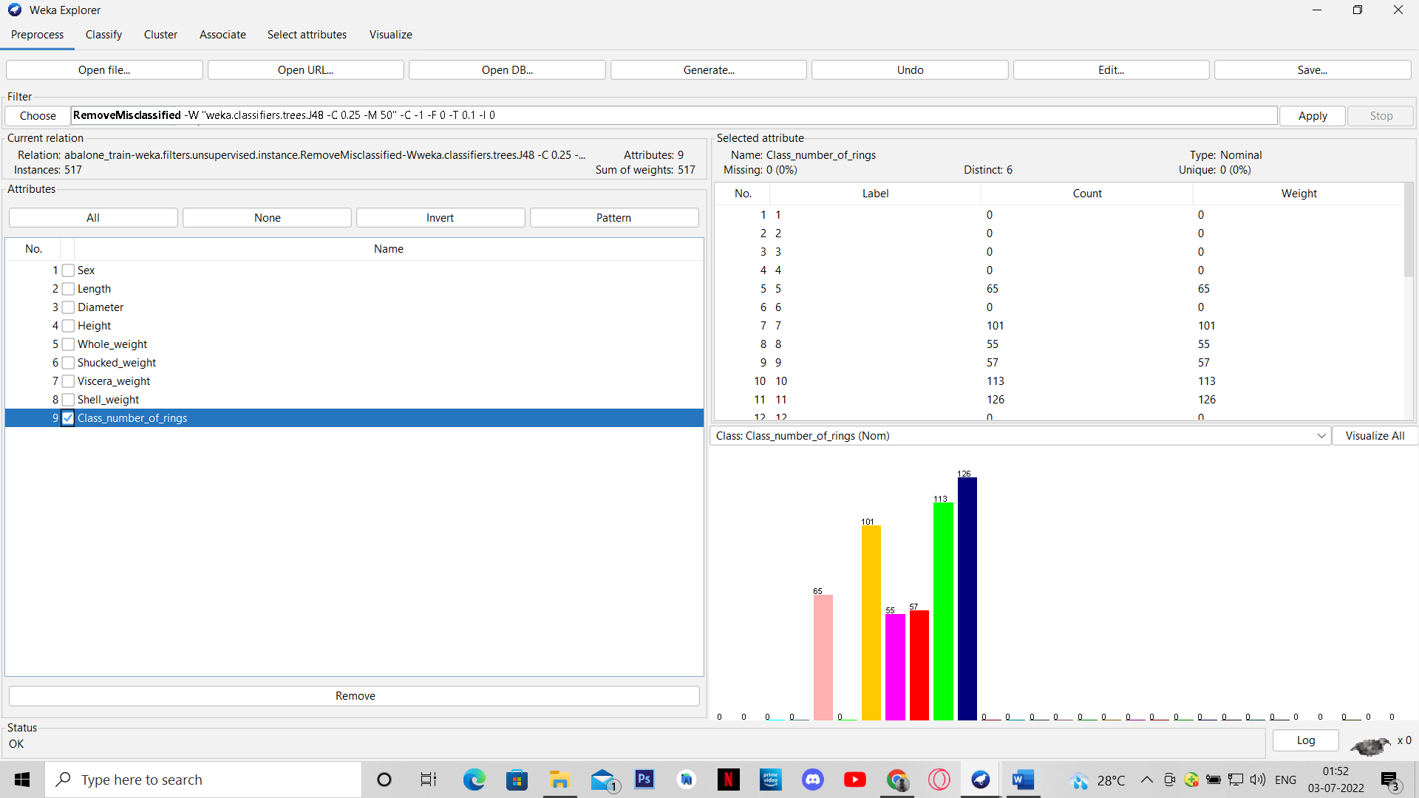

Building the classification model

Training:

Algorithm: J48 Decision Tree

Decision tree generated

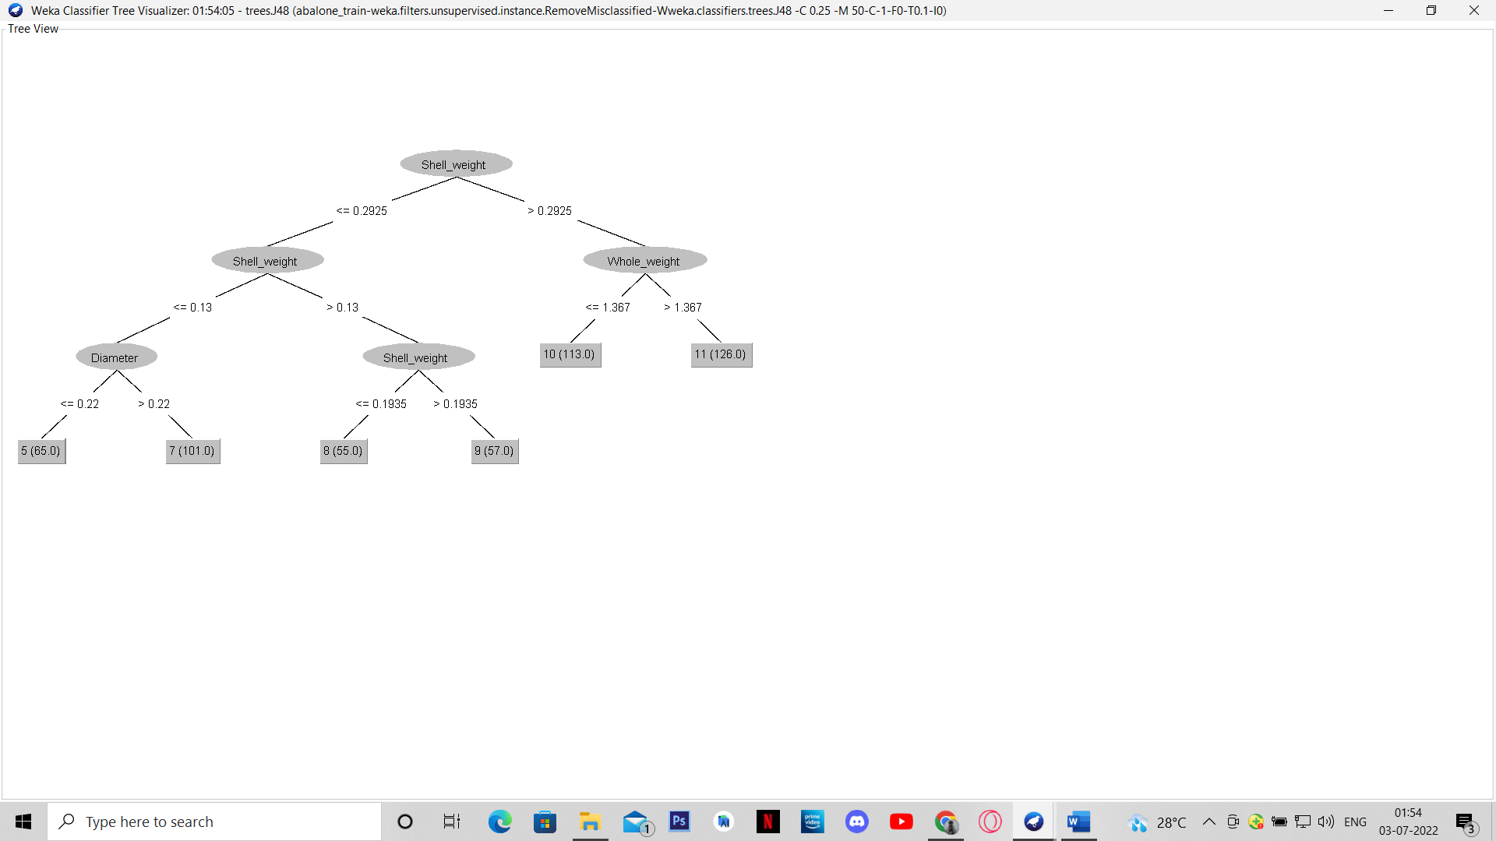

Testing:

Using the model built above

Prediction of number of rings

(taken 35 instances for screenshot)

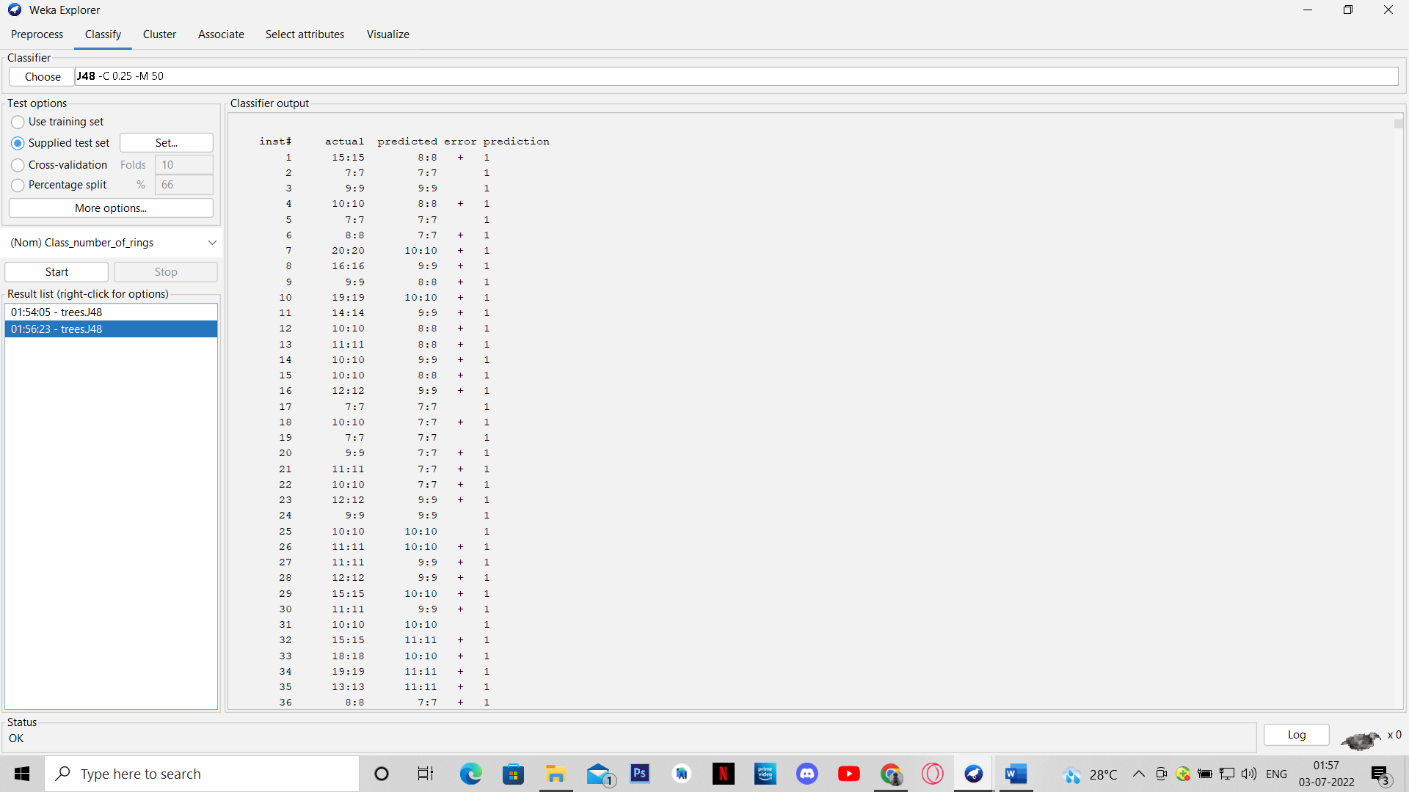

Accuracy

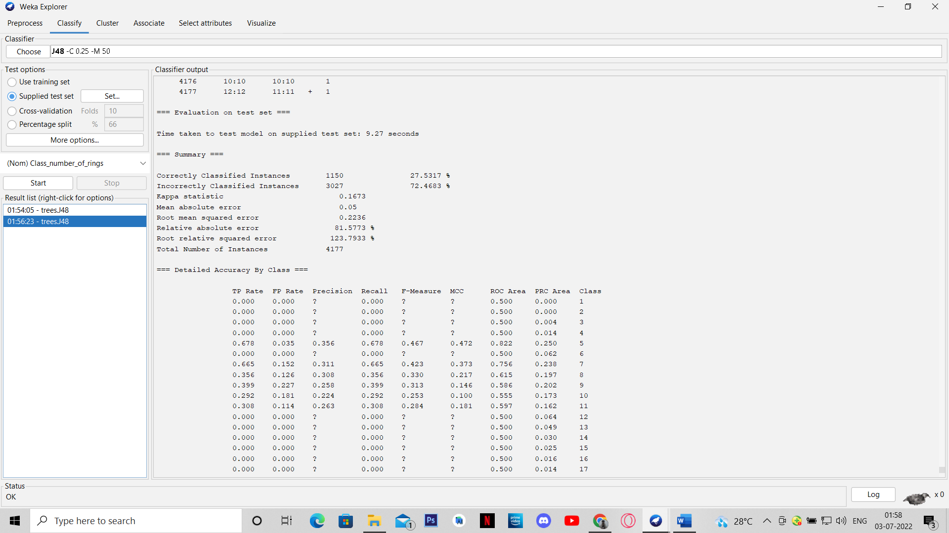

Confusion Matrix

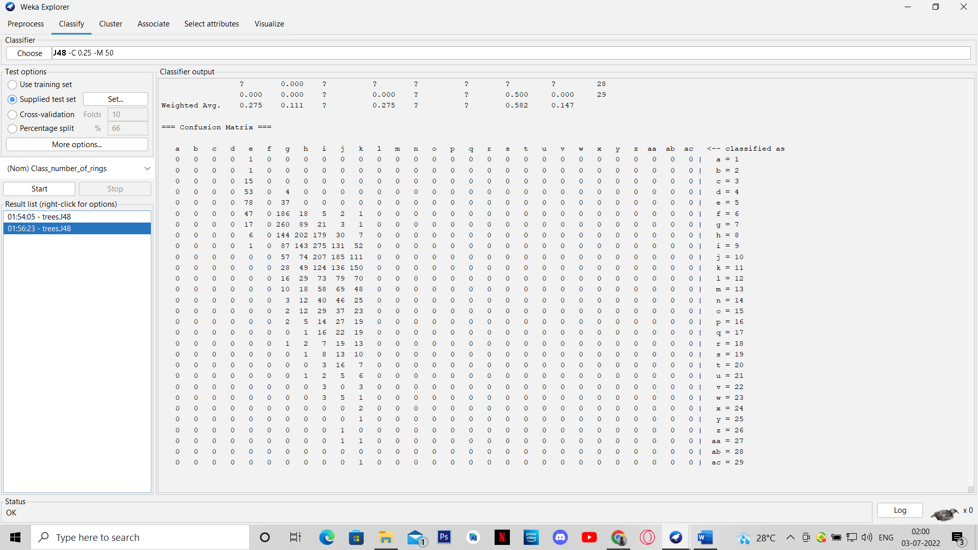

Approach 2: Predicting the age

Data Pre-processing

Filter: Discretize

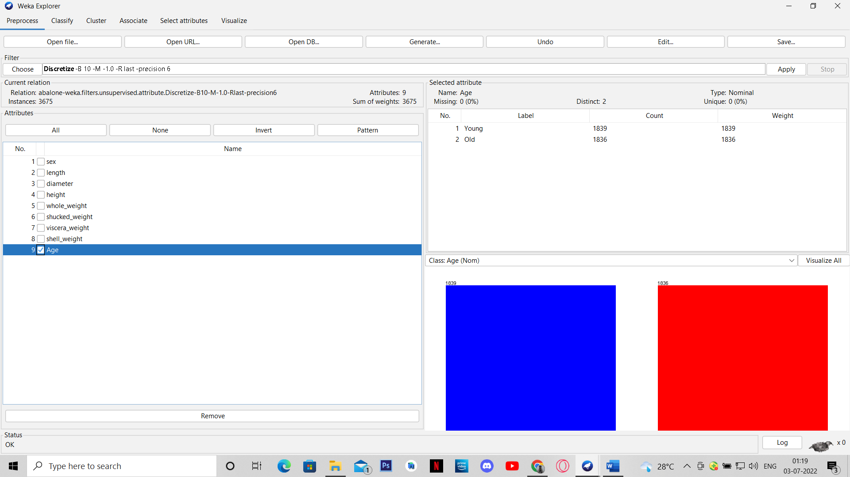

Building the classification model

Training:

J48 Decision Tree

Decision tree generated

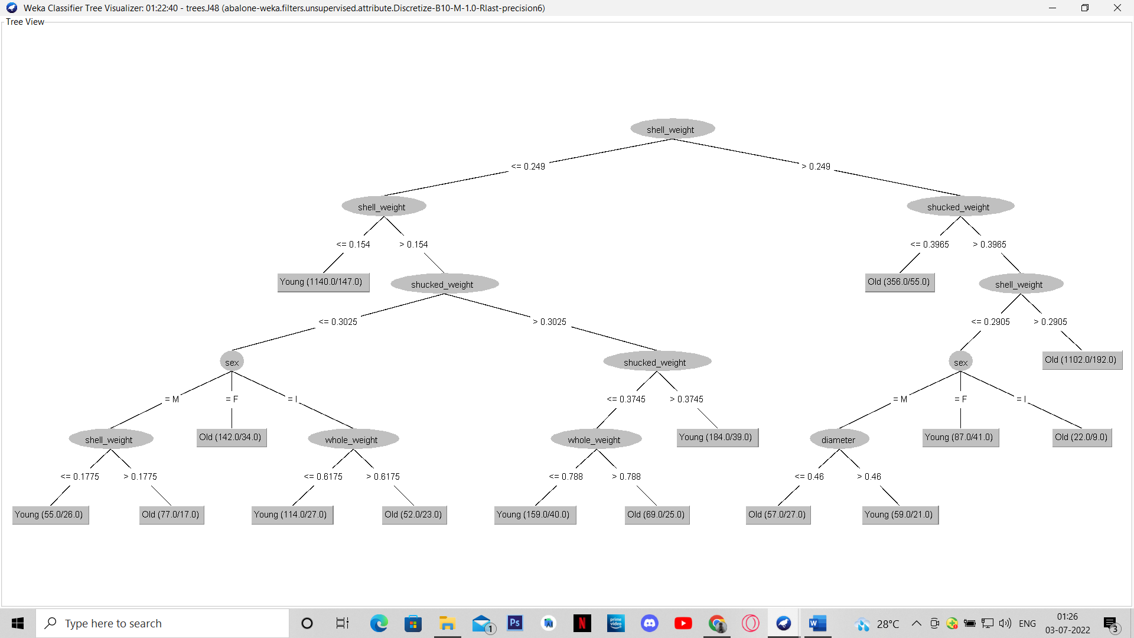

Testing:

Using the model built above

Prediction of age

(taken 35 instances for screenshot)

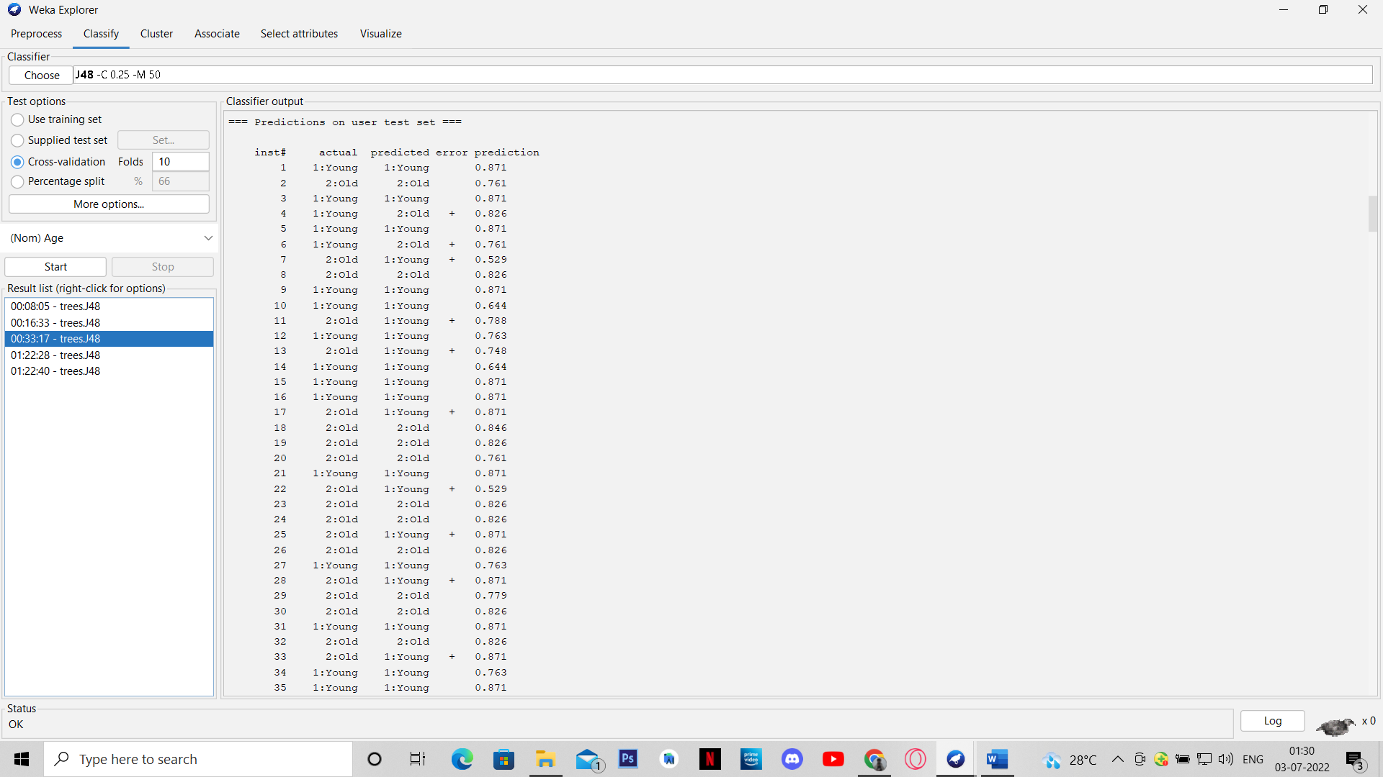

Accuracy + Confusion matrix

